**Exercise 4: Functions**

**Scenario 1:** Calculate the age of customers for eligibility checks.

* + **Question:** Write a function CalculateAge that takes a customer's date of birth as input and returns their age in years.

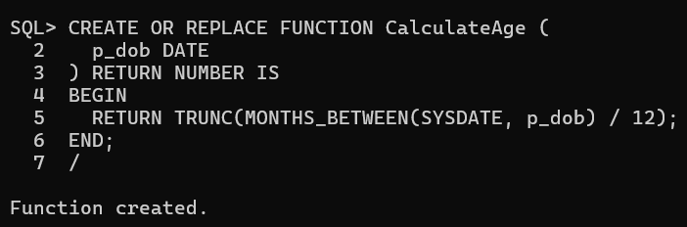

**Scenario 2:** The bank needs to compute the monthly installment for a loan.

* + **Question:** Write a function **CalculateMonthlyInstallment** that takes the loan amount, interest rate, and loan duration in years as input and returns the monthly installment amount.

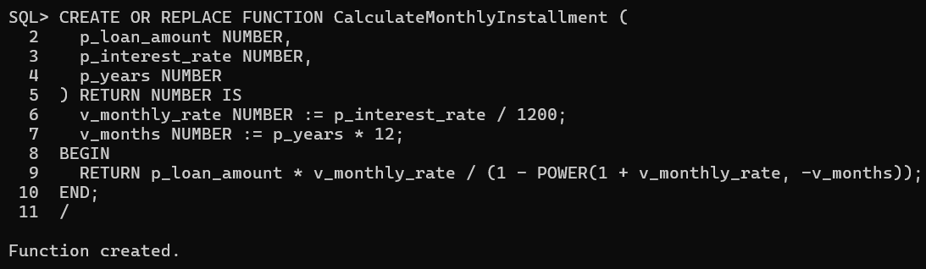

**Scenario 3:** Check if a customer has sufficient balance before making a transaction.

* + **Question:** Write a function **HasSufficientBalance** that takes an account ID and an amount as input and returns a boolean indicating whether the account has at least the specified amount.

